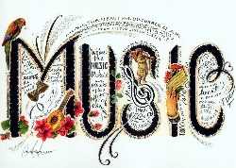 January 9, 2015

Dear SCHS Music Families,

The SCHS Music Boosters is pleased to be able to offer 5-$200 scholarships to choir students and 5-$200 scholarships to band students.
This money is to be used for marching band camp, private lessons, band or choir trip, other music camps or Summer Music Theatre.
Please read the directions carefully and apply to earn this generous scholarship. Our hope is that by offering this award, students will enhance their personal music skills, which will also enhance SCHS’s music program.

Best Regards

Mandy Steen
SCHS Music Booster Scholarship Coordinator

